Zero-shot Prompting
To build an effective travel planner for Spain, we need to break the trip down into logistical components. Spain is regionally diverse, so a "one-size-fits-all" plan rarely works.
Here is a comprehensive framework to plan your trip, covering the essential phases from preparation to the daily itinerary.

Phase 1: The Logistics (The "Before" Checklist)
- Determine the Season:
  - High Season (June–August): Hot, crowded, expensive, but all attractions are open. Best for beaches.
  - Shoulder Season (March–May, Sept–Oct): Ideal weather (mild), fewer crowds. Best for sightseeing and hiking.
  - Low Season (Nov–Feb): Cold in the interior, mild in the south. Many beach towns shut down, but cities (Madrid, Barcelona, Seville) remain lively.
- Duration:
  - 7 Days: Focus on 1 region (e.g., Andalusia or Catalonia).
  - 10–14 Days: Combine 2 regions (e.g., Madrid + Andalusia or Barcelona + Madrid + Seville).
  - 21+ Days: The "Grand Tour" (North to South).
- Transport Mode:
  - High-Speed Train (AVE): Best for connecting major hubs (Madrid, Barcelona, Seville, Valencia). Book in advance.
  - Car Rental: Essential for the Northern Coast, Pueblos Blancos (White Villages), or Costa Brava.
  - Bus (ALSA): Reliable for smaller towns not served by trains.

Phase 2: Choose Your Route
Select one of these "tracks" based on your interests.

Track A: The Classics (First-Timers)
- Focus: History, Art, Major Landmarks.
- Stops: Madrid (Prado Museum, Royal Palace) → Toledo (Day trip) → Seville (Alcázar, Plaza de España) → Granada (Alhambra) → Barcelona (Sagrada Família, Park Güell).

Track B: Sun & Moorish History (Andalusia Deep Dive)
- Focus: Architecture, Flamenco, Tapas, Warmth.
- Stops: Seville → Córdoba (Mezquita) → Ronda (The Gorge) → Granada → Málaga (Beaches).

Track C: Food & Greenery (The North)
- Focus: Michelin stars, Pintxos, Rugged Coastlines, Mountains.
- Stops: San Sebastián (Food capital) → Bilbao (Guggenheim) → Picos de Europa (Hiking) → Oviedo.

Track D: Mediterranean Coast
- Focus: Beaches, Modernism, Nightlife.
- Stops: Barcelona → Valencia (City of Arts and Sciences, Paella) → Alicante.

Phase 3: Sample 10-Day Itinerary (The "Classics" Hybrid)
This is a balanced route that covers the two biggest cities and the cultural heart of the south.
Day | Location | Key Activity
1 | Madrid | Arrive, Plaza Mayor, Mercado de San Miguel for tapas.
2 | Madrid | Prado Museum (morning), Retiro Park (afternoon).
3 | Toledo | Day trip (30 min train). Medieval streets, swords, marzipan.
4 | Seville | Train to Seville (2.5 hrs). Sunset at Metropol Parasol.
5 | Seville | Real Alcázar (Game of Thrones set), Cathedral, Flamenco show.
6 | Granada | Train/Bus to Granada. Tea houses in Albayzín district.
7 | Granada | The Alhambra (Book 3 months in advance!).
8 | Barcelona | Flight or long train to Barcelona. Gothic Quarter walk.
9 | Barcelona | Sagrada Família (Inside is a must), Park Güell.
10 | Barcelona | Beach promenade or Casa Batlló. Depart.

Phase 4: Budget Planner (Estimates)
Category | Budget (€50-80/day) | Mid-Range (€120-180/day) | Luxury (€250+/day)
Accommodation | Hostels / Shared Airbnb | Boutique Hotels / Private Airbnb | 5-Star Hotels / Paradors
Food | Supermarket / Menu del Día | Tapas hopping / Nice bistros | Michelin / Fine Dining
Transport | Bus / BlablaCar | AVE Trains (Standard) | 1st Class Rail / Private Transfers
Attractions | Free walking tours / Exterior views | Museum Entry / Guided Tours | Private Guides / VIP Access

Phase 5: Essential "Know Before You Go"
- Eating Times: Lunch is 2:00 PM – 4:00 PM. Dinner is 9:00 PM – 11:00 PM. Many kitchens close between 4:00 PM and 8:00 PM.
- Tipping: Not mandatory. Rounding up or leaving 10% for exceptional service is polite, but not expected like in the US.
- Siesta: In small towns and the south, shops often close from 2:00 PM to 5:00 PM. Big city centers usually stay open.
- Water: Tap water is safe to drink in 99% of Spain (though the taste varies; Madrid has excellent water, coastal areas less so).

Would you like me to refine this into a specific day-by-day plan for a particular month or interest (e.g., "7 days in May focused on food")?

RTF Prompting
This is a comprehensive travel planner for a 10-day trip to Spain, optimized for a traveler coming from Egypt.

Phase 1: Pre-Trip Logistics (Egypt → Spain)
- Visa: You will need a Schengen Visa. In Egypt, this is processed through BLS International (for Spain). Apply at least 1-2 months in advance.
- Flights:
  - Direct: EgyptAir and Iberia fly direct from Cairo (CAI) to Madrid (MAD) or Barcelona (BCN).
  - Flight Time: Approx. 5 hours 20 minutes.
- Internal Transport: The high-speed AVE trains are the best way to move between cities. Book these tickets 2-3 months early for the best prices.

Phase 2: The 10-Day "Classics" Itinerary
This route covers the "Golden Triangle" of Spanish tourism: Madrid (History), Andalusia (Culture), and Barcelona (Architecture).
Day | City | Morning | Afternoon/Evening | Visual Highlight
1 | Madrid | Arrive in Madrid. Check into hotel near Gran Vía. | Walk to Plaza Mayor and eat dinner at Mercado de San Miguel. | The Golden Glow: Imagine an iron-and-glass market glowing warm yellow at night, filled with piles of colorful olives, hanging jamón ibérico legs, and fresh seafood tapas.
2 | Madrid | Prado Museum (Goya & Velázquez masterpieces). | Sunset at the Temple of Debod (an ancient Egyptian temple gifted to Spain). | Ancient Stone: A genuine Egyptian temple standing on a Spanish hill, silhouetted against a fiery purple and orange Madrid sunset.
3 | Toledo | Day trip by train (30 mins). Visit the Cathedral and Alcázar. | Walk the medieval streets. Buy Marzipan (local sweet). Return to Madrid. | The City on a Hill: A panoramic view of a medieval city tightly packed on a rocky mountaintop, surrounded on three sides by a deep blue river.
4 | Seville | High-speed train to Seville (2.5 hrs). Check in. | Visit Plaza de España. Take a boat row in the canal. | Tile Masterpiece: A massive semi-circular brick building hugged by a canal, decorated with thousands of bright blue, yellow, and white ceramic tiles depicting Spanish provinces.
5 | Seville | Real Alcázar (Moorish Palace). Book tickets 1 month ahead! | Watch a genuine Flamenco Show in the Triana neighborhood. | Lace in Stone: Intricate Islamic geometric carvings on archways that look like delicate lace, surrounding lush courtyards with orange trees and fountains.
6 | Granada | Train to Granada. Check into hotel. | Walk through the Albayzín (old Arab quarter) for tea and sunset views. | White & Green: Narrow, winding cobblestone streets lined with stark white houses, spilling over with pink bougainvillea flowers, looking out toward the mountains.
7 | Granada | The Alhambra & Generalife Gardens. Book 3 months ahead! | Dinner of free tapas (Granada tradition: buy a drink, get free food). | The Red Fortress: The massive red clay walls of the Alhambra resting against the backdrop of the snow-capped Sierra Nevada mountains.
8 | Barcelona | Fly or long train to Barcelona. | Walk down La Rambla and explore the Gothic Quarter. | Medieval Maze: Dark, narrow stone alleyways that suddenly open up into bright, sunny squares filled with cafe tables and cathedral spires.
9 | Barcelona | Sagrada Família (Inside tour is essential). | Park Güell for city views and gingerbread-style houses. | Forest of Stone: Inside the Sagrada Família, massive pillars rise up and branch out like trees, with stained glass filling the space with rainbows of light.
10 | Barcelona | Casa Batlló (The "Dragon" house). | Last minute shopping / Beach walk at Barceloneta. Depart. | The Dragon's Back: A colorful, wavy roof that looks like reptile scales in shimmering iridescent blues, greens, and purples.

Phase 3: Journey Visuals
Since I cannot display image files directly, here is a descriptive guide to the iconic scenes you will encounter on this journey.

1. The Royal Majesty of Madrid
- The Scene: The Royal Palace (Palacio Real).
- Description: A colossal white baroque palace with over 3,000 rooms. It sits across a vast limestone courtyard. When the sun hits it, the white stone is blindingly bright against the deep blue Spanish sky.

2. The Andalusian Dream (Seville)
- The Scene: Plaza de España.
- Description: Famous from Star Wars, this is a spectacle of brick and tile. You will see bridges with blue ceramic railings crossing a moat where visitors row small boats. The air smells of orange blossoms from the nearby park.

3. The Crown Jewel (Granada)
- The Scene: The Alhambra.
- Description: This is the most famous view in Spain. From the viewpoint of San Nicolás, you see the Alhambra palace complex sitting atop a green hill. Behind it, the high peaks of the Sierra Nevada are often covered in white snow, creating a stunning contrast with the red fortress walls.

4. The Modernist Marvel (Barcelona)
- The Scene: Sagrada Família Interior.
- Description: Unlike dark, gloomy cathedrals, this interior feels like a magical forest. The light filtering through the stained glass is cool blues and greens on the east side (sunrise) and warm reds and oranges on the west side (sunset), painting the white stone floor in color.

Next Steps for You
- Visa: Have you checked the current appointment availability at BLS International in Egypt? Slots can fill up fast.
- Booking: Would you like me to find the specific train times between Madrid and Seville for your travel dates?

Emotion Prompting

1. The Master Plan
This is where it all begins. A snapshot of your travel journal, mapping out your route from Madrid to Seville and finally to Barcelona.
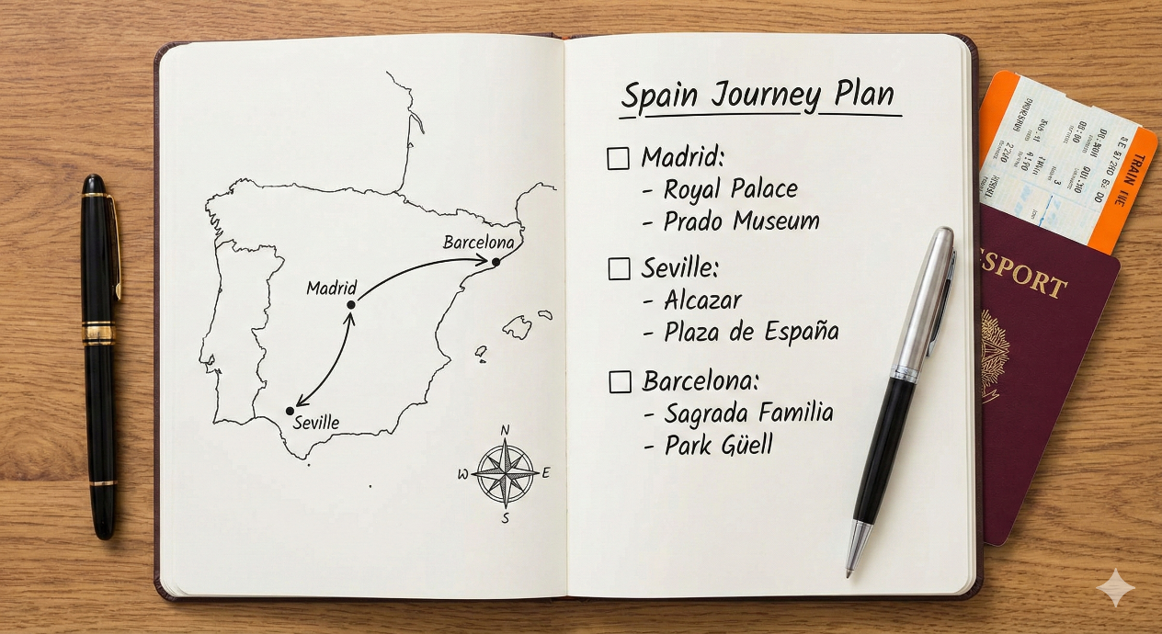

2. First Stop: Royal Madrid
A moment of awe as you stand before the magnificent Royal Palace in Madrid, the first major landmark on your list.

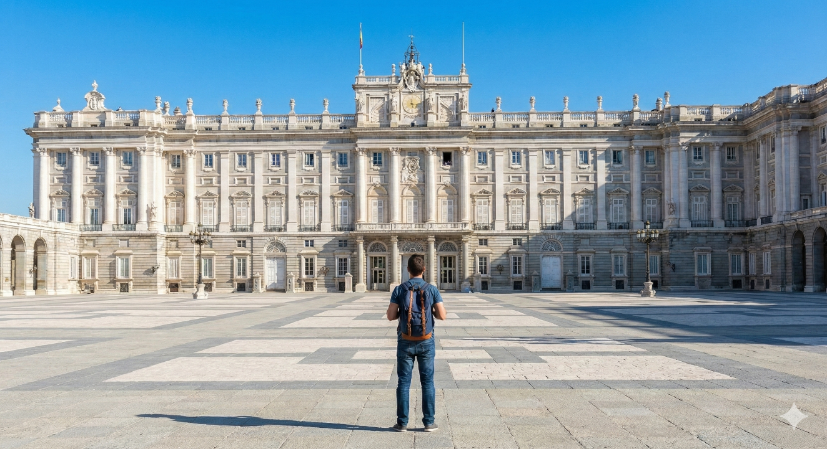

3. Second Stop: Stunning Seville
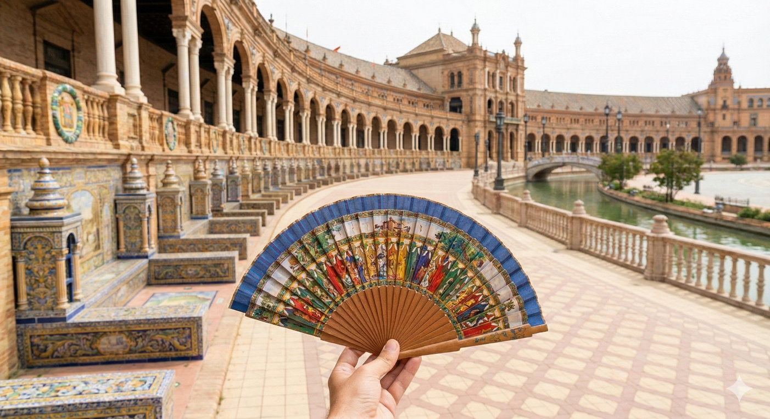
Immersing yourself in the culture of Andalusia. A personal photo from the breathtaking Plaza de España in Seville.

4. Final Stop: Beautiful Barcelona
Capturing the incredible details of the Sagrada Familia, the final and most iconic stop on your Spanish journey.
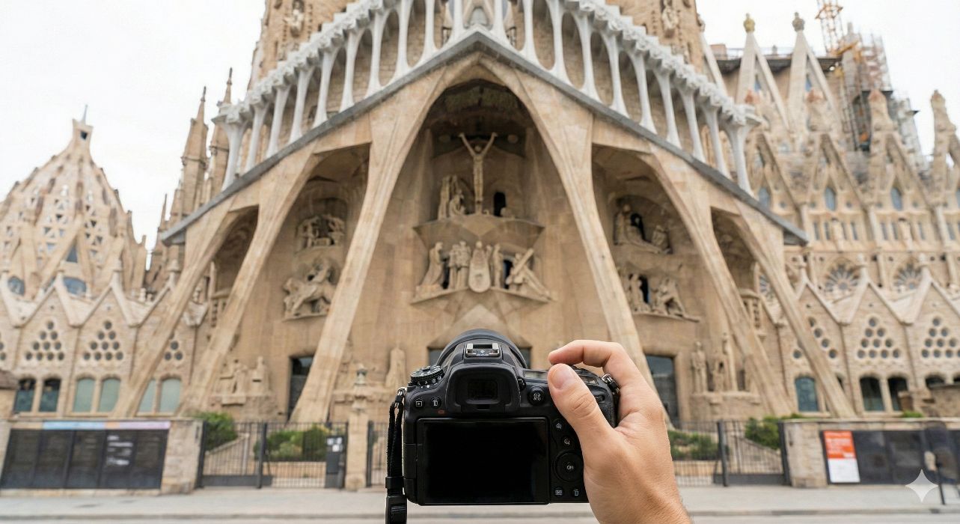

5. The Completed Journey
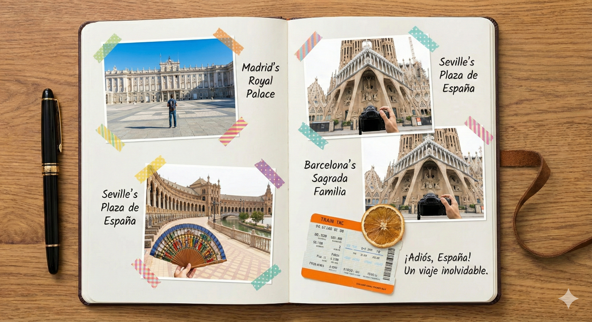
The final journal entry, a cherished scrapbook of an unforgettable solo adventure. The plan has been fulfilled and the memories are preserved forever.

This collection of images tells the story of your entire journey, from the initial planning to the final memories. I hope it inspires you for your trip!

